FAC Algorithmic Trading A0



**M O N E Y B A L L**

**with MONEYBALL**

~*pratyushjuyal07*

# Market value vs Intrinsic value

In the movie, Peter and Billy have a parking lot conversation in which the subject is Damon, a star player they just lost to the rival team. Peter emphasizes that Damon was highly overvalued and losing him opened up ‘all kinds of possibilities’ and that Damon was not worth the high fee.

Traditional scouting methods discard relevant metrics and instead value many players emotionally(a future point), leading to under- and over-valuation of players. This is relevant in terms of financial instruments like stocks as well, the market value of some stocks might be higher/lower than their intrinsic value.

# Budgeting

In the movie, budgeting, discussion, and draft meetings were held in many scenes, with other scouts, managers, and the owner.

This is of utmost importance in corporate settings and businesses, or even in personal finance. Budgeting is a way of future planning and risk aversion.

# Emotion ruins business

In the movie, it is seen that other scouts often include irrelevant factors like age, looks, personality, disability, relationships, and other off-field characteristics when valuing players.

This provides a stark contrast between their perceived and actual value.

Billy employs measures like distancing himself from the players to ensure that he is not forming personal connections that may cloud his mindset.

In the financial world too, emotions can lead to wrong decisions pretty quickly. Forming connections with certain instruments, stocks, or entities due to personal reasons and emotions may prove to be a significant future downturn. Additionally, emotions like greed, overconfidence, FOMO, fear, and impatience make mental waters murky.

# Valuation: getting all metrics down to a singular number

In the movie, Peter is seen explaining that he has a code that ‘gets things down to one number; using stats the way we[they] read them to find value in players nobody else sees’. This cuts emotion through math and finds the intrinsic value of all players.

In finance, there are similar financial formulae that take in multiple metrics(like assets, liabilities, working capital, earnings, sales, and cash flow) and pump out a single number. Some examples include:

* 1. Altman Z-score: measures the likelihood of a company going bankrupt
  2. Piotroski F-score: measures the financial strength of a company
  3. Beneish M-score: detects potential earnings manipulation; cooking the books
  4. KZ index: measures financial constraints

# Drafting undervalued players

In the movie, Peter explains that a player named Chad Bradford is the epitome of undervaluation in the market. While his actual value is around $3 million, everyone disregards him because ‘he throws funny and looks funny’. This way, they snag him for a tenth of his true value. And when the time comes, he proves to be one of the best pitchers in the league.

When choosing companies, entities, and stocks to invest in, market analysis helps to a large extent, enabling one to find hidden gems and undervalued picks.

# Portfolio management/correction

In the movie, the managers are often cutting or signing new players to increase the team’s synergy. This involved trades, buying or selling players, and interaction with rival teams.

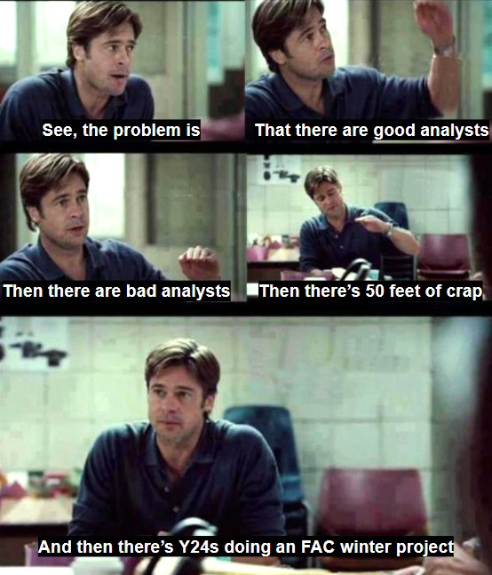This concept is not new in the financial landscape. Asset management often involves reshaping the portfolio and correcting any mistakes made, removing unfavourable picks, and adding promising selections.

# Leverage and negotiation tactics

In a specific scene, we see that Billy understands competitor (Cleveland Indians) requirements and constraints (that the Indians must sell Richard Rincon).

He leveraged the information by making a side-deal with a third-party, so that this party was no longer required to buy from the Indians.

Left without a buyer for their player, the Indians are forced to sell to Billy, who cunningly also fooled his boss into buying Rincon, despite his initial disapproval.